**Road Closure**

*User manual*

**Abstract**

The Road Closure tool is a webtool that will enable properly authorized users to create maps of road closures and will allow maps to be saved as a .PDF to allow for easy distribution.

The user will be identified via a unique username and password. An authenticated user will be able to access all of their previously saved maps as well as being able to edit them and create new maps. While editing a map, the user will be able to draw and annotate lines, circles, specific points, and boxes.

This document contains the manual of how to use Road Closure. The rest of this document is structured as follows. Chapter 1 contains the introduction. This chapter presents a brief description of the system. Chapter 2 outlines the functional requirements of the system.

This document describes functionality of Road Closure v. 1.0, dated 21 April 2017.

Table of Contents

1 System overview 1

1.1 Program interface 1

1.2 System requirements 2

2 Login 3

2.1 Login Overview 3

2.1.1 Data structure for Login 3

2.2 Login Instructions 3

2.3 Sample Failed Login 4

2.4 Sample Successful Login 4

3 Logout 5

3.1 Logout Overview 5

3.2 Logout Instructions 5

4 CreateMap 6

4.1 CreateMap overview 6

4.2 CreateMap Instructions 6

4.2.1 Map Name 7

4.2.2 Map Description 7

5 EditMap 8

5.1 EditMap overview. 8

5.2 EditMap Instructions 8

5.3 EditMap ToolBox 8

6 Delete Map 8

7 Publish Map 8

8 Other functionality 8

8.1 Select Map 8

8.2 Errors 8

# System overview

## Program interface

Road Closure includes a set of interactive user interfaces as displayed in Figure 1.1, 1.2, and 1.3. All system functionality is accessible through the three following interfaces.

Figure 1.1 Login interface

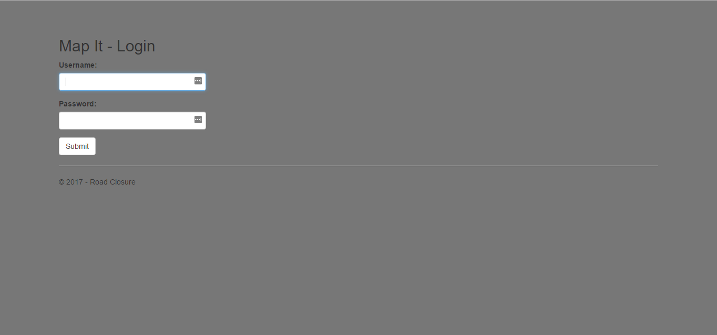

Figure 1.2 ListMap interface

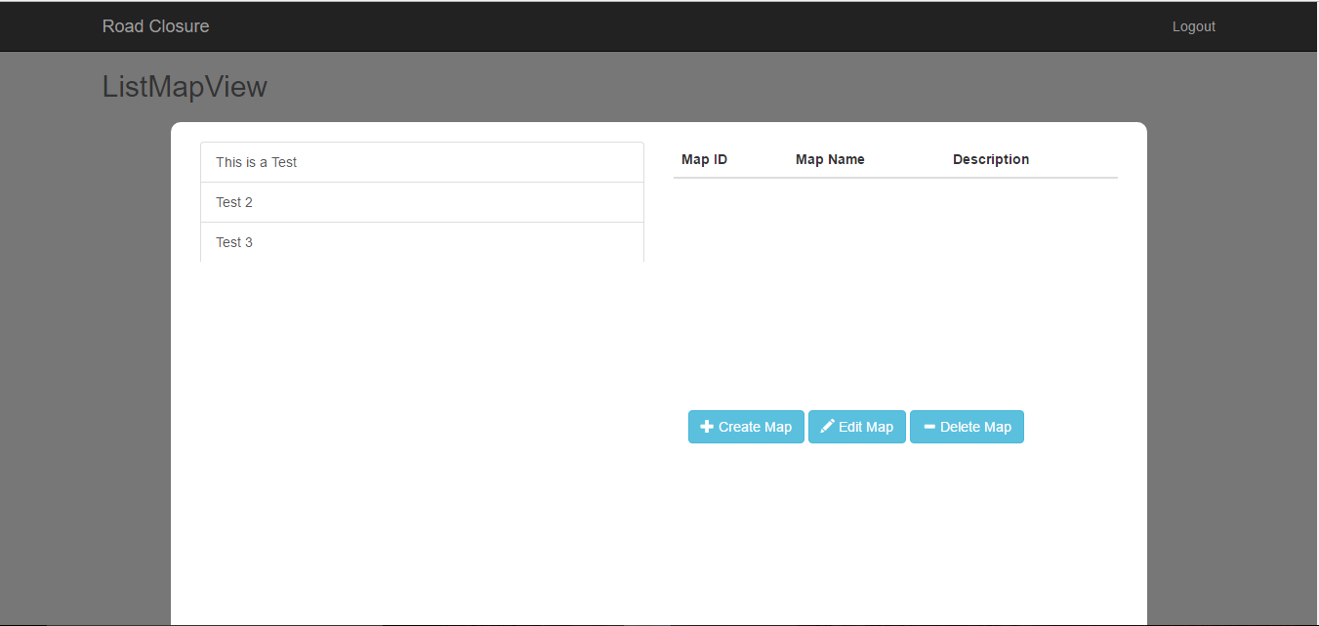

Figure 1.3 EditMap interface

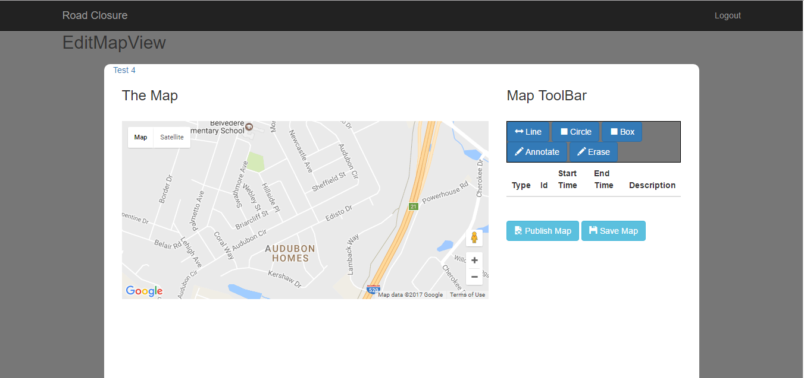

## System requirements

Road Closure is written in C# and Javascript. The system also has a web dependency of the Google Maps API. User must use a Javascript enabled browser and have a connection to the internet to use this application.

# Login

## Login Overview

Road Closure is a secure system that only allows a specific set of users to use the application. The user account must already be stored in the system database to Login to the system.

### Data structure for Login

The user will use a unique username and password to Login into the system. The unique username and password must match the information in the system database.

## Login Instructions

The User must enter a username in 2.2a and a password in 2.2b. Figure 2.2 is the Login interface.

Figure 2.2

2.2b

2.2a

2.2c

After the User enters in their credentials, the user must select the submit button or 2.2c to see if access to the application is granted.

## Sample Failed Login

If the incorrect credentials are submitted into Road Closure. A message like 2.3a will display to the user. This message is too educate the user that a unsuccessful login attempt occurred.

Figure 2.3 *Update: This image will be updated



## Sample Successful Login

If the User is successfully authenticated the ListMap interface will display.

# Logout

## Logout Overview

Road Closure supports the ability for multiple users to interact with the application on one machine. The system was designed for multiple user accounts. To access another account or when the user is trying to close out of the application. The user will use the Logout function.

## Logout Instructions

On the ListMap and EditMap interface, a Logout button can be seen at the top right corner of the page or as shown in Figure 3.2a and 3.2b. The system will then redirect the User to the Login page.

Figure 3.2



3.2a

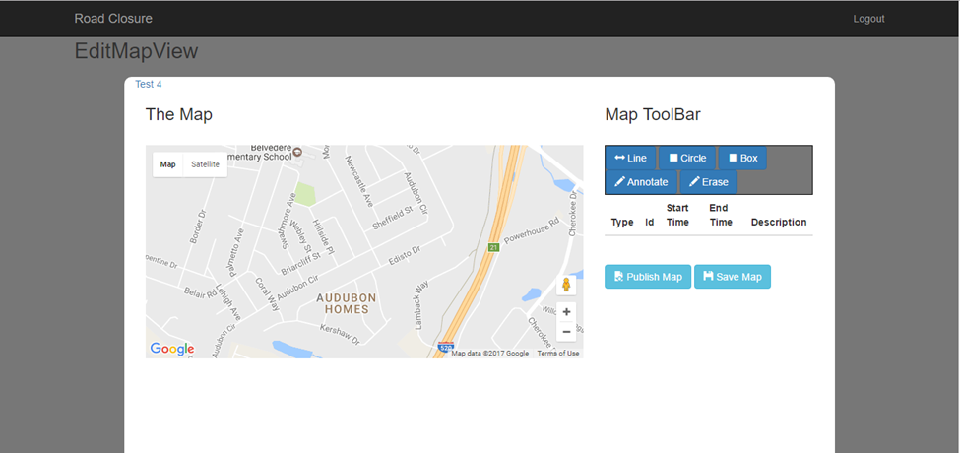

3.2b

# CreateMap

## CreateMap overview

One of the core functionalities of Road Closure is the ability for a User to save customer road closures as maps to their user account. This allows the user to have multiple maps or road closures at different areas and is saved for future use.

## CreateMap Instructions

The Create Map button is located on the ListMap interface or shown in Figure 4.2a. The user can click the Create Map Button and a Modal will appear with a Textbox for Map Name and Map Description. A Submit button and Close button are also displayed on the Modal. The Modal is shown as Figure 4.2b

Figure 4.2 Create Map Button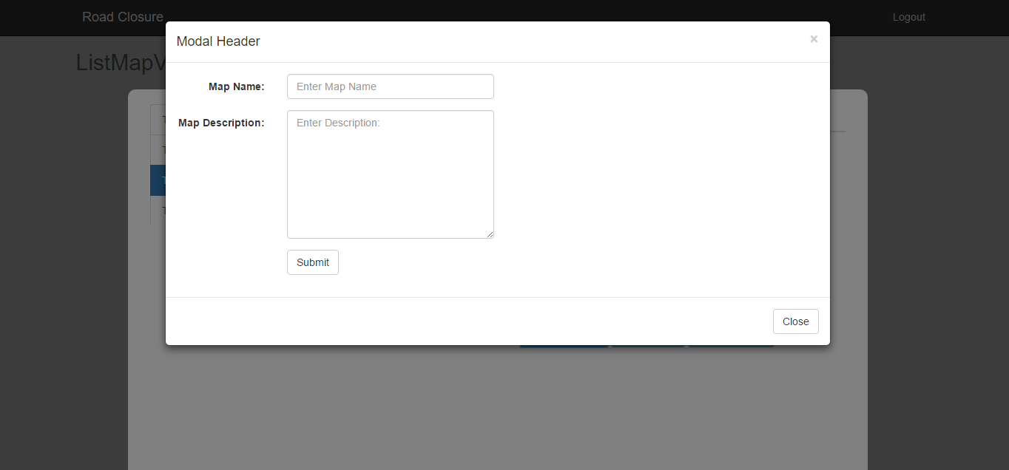

### Map Name

In this Text box, the User can create a unique name for the map they are creating. This information will be shown as map details in the Select Map functionality.

### Map Description

In this Text box, the User can create a unique description for the map they are creating. This information will be shown as map details in the Select Map functionality.

.

# EditMap

## EditMap overview.

## EditMap Instructions

## EditMap ToolBox

# Delete Map

# Publish Map

# Other functionality

## Select Map

Road Closure will display some brief information for a selected map on the ListMap interface. The User can click any of the maps located in the Listbox. The system will respond with a brief description displayed on the right side of the page.

## Errors